**DAILY ONLINE ACTIVITIES SUMMARY**

|  |  |  |  |  |  |  |  |
| --- | --- | --- | --- | --- | --- | --- | --- |
| **Date:** | **13 July 2020** | | | | **Name:** | **Sinchana K N** | |
| **Sem & Sec** | **4th sem, 2nd year** | | | | **USN:** | **4al18cs083** | |
| **Online Test Summary** | | | | | | | |
| **Subject** | | **MICROCONTROLLER AND EMBEDDED SYSTEMS (18CS44)** | | | | | |
| **Max. Marks** | | **30** | | **Score** | | **---** | |
| **Certification Course Summary** | | | | | | | |
| **Course** | **Introduction to HTML5** | | | | | | |
| **Certificate Provider** | | | **GreatLearning, coursera** | **Duration** | | | **12 hrs** |
| **Coding Challenges** | | | | | | | |
| **Problem Statement: 1** | | | | | | | |
| **Status: executed** | | | | | | | |
| **Uploaded the report in Github** | | | | **Yes** | | | |
| **If yes Repository name** | | | | **lockdown_coding1** | | | |
| **Uploaded the report in slack** | | | | **Yes** | | | |

#### Online Exam:

#### Today MICROCONTROLLER AND EMBEDDED SYSTEMS (18CS44) was conducted for 30 marks from 9:30-10:30 AM.

#### Certification Course Summary:

#### Today I continued Introduction to HTML5 in Coursera which is of 12hrs course.

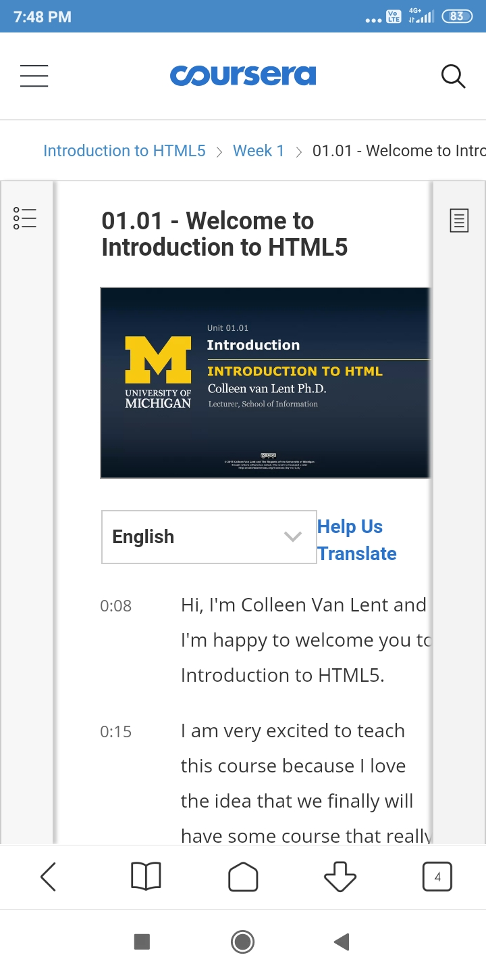

**Online coding:**

**Write a Java Program to find the duplicate characters in a string.**

